WSL (Windows Subsystem for Linux) is a feature in Windows that lets you run a real Linux environment (like Ubuntu) directly inside Windows.
wsl --install
wsl --install -d Ubuntu
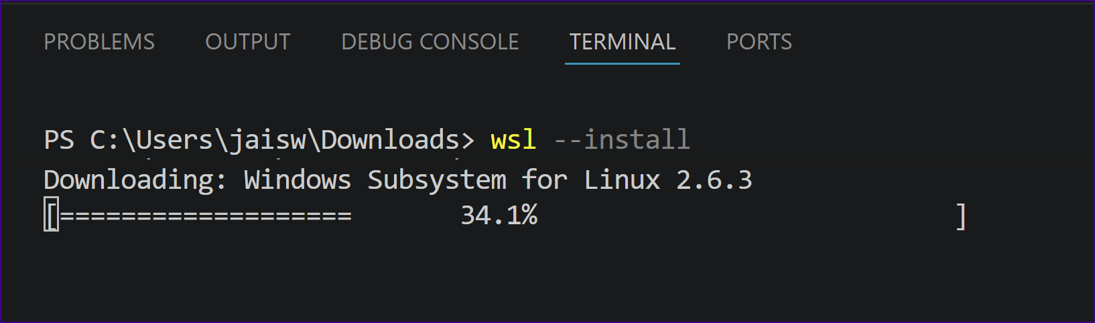

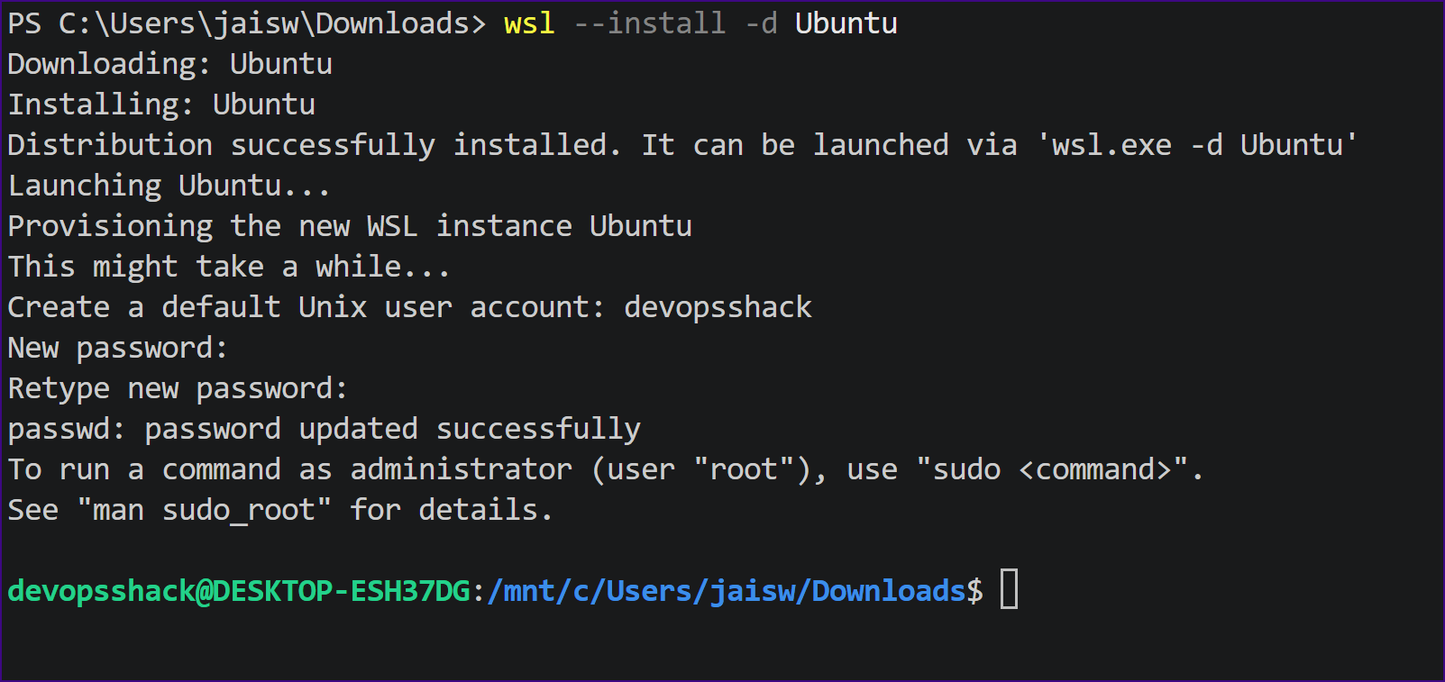

1) Install NVM
curl -o- https://raw.githubusercontent.com/nvm-sh/nvm/v0.39.7/install.sh | bash
Reload shell:
source ~/.bashrc
Verify:
nvm --version

2) Install Node.js (LTS)
nvm install --lts
Set default:
nvm use --lts
nvm alias default lts/*

3) Verify installation
node -v
npm -v
You should see something like:
- Node: v18.x or v20.x

4) (Optional but recommended)
Install useful global tools:
npm install -g nodemon

Install MySQL
In WSL Ubuntu:
sudo apt update
sudo apt install mysql-server -y
Start MySQL:
sudo service mysql start
Check status:
sudo service mysql status
Login to MySQL:
sudo mysql

Run:
CREATE DATABASE IF NOT EXISTS test_db;
CREATE USER 'appuser'@'localhost' IDENTIFIED WITH mysql_native_password BY 'password123';
GRANT ALL PRIVILEGES ON test_db.* TO 'appuser'@'localhost';
FLUSH PRIVILEGES;
Then create table:
USE test_db;
CREATE TABLE IF NOT EXISTS users (
id INT AUTO_INCREMENT PRIMARY KEY,
name VARCHAR(255) NOT NULL,
email VARCHAR(255) NOT NULL UNIQUE,
role ENUM('Admin', 'User') NOT NULL
);
Exit:
EXIT;

